GDB Demonstration Document   

/\*\*\*\*\*\*\*\*\*\*\*\*\*\*\*\*\*\*\*\*\*\*\*\*\*\*\*\*\*\*\*\*\*\*\*\*\*\*\*\*\*\*\*\*\*\*\*\*\*\*\*\*\*\*\*\*\*\*\*\*\*\*\*\*\*\*\*\*\*\*\*

        This Code uses two functions to find the sum and product.

        Sum finds the sum of two numbers.

        Product finds the product of two numbers.

\*\*\*\*\*\*\*\*\*\*\*\*\*\*\*\*\*\*\*\*\*\*\*\*\*\*\*\*\*\*\*\*\*\*\*\*\*\*\*\*\*\*\*\*\*\*\*\*\*\*\*\*\*\*\*\*\*\*\*\*\*\*\*\*\*\*\*\*\*\*\*/

#include<stdio.h> int sum(int, int);

int product(int, int);

int main() {

        int x,y;         x=5;

        y=20;

        printf("The Sum is %d\n",sum(x,y));

        printf("The Product is %d\n",product(x,y));

         }

/\*\*\*\*\*\*\*\*\*\*\*\*\*\*\*\*\*\*\*\*\*\*\*\*\*\*\*\*\*\*\*\*\*\*\*\*\*\*\*\*\*\*\*\*\*\*\*\*\*\*\*\*\*\*\*\*\*\*\*\*\*\*\*\*\*\*\*\*\*\*\*

        Function Sum finds the sum of two integers

\*\*\*\*\*\*\*\*\*\*\*\*\*\*\*\*\*\*\*\*\*\*\*\*\*\*\*\*\*\*\*\*\*\*\*\*\*\*\*\*\*\*\*\*\*\*\*\*\*\*\*\*\*\*\*\*\*\*\*\*\*\*\*\*\*\*\*\*\*\*\*/

int sum(int a , int b)

{

        int s;         s=a+b;         return(s);

}

/\*\*\*\*\*\*\*\*\*\*\*\*\*\*\*\*\*\*\*\*\*\*\*\*\*\*\*\*\*\*\*\*\*\*\*\*\*\*\*\*\*\*\*\*\*\*\*\*\*\*\*\*\*\*\*\*\*\*\*\*\*\*\*\*\*\*\*\*\*\*\*

        Function Product finds the product of two integers.

\*\*\*\*\*\*\*\*\*\*\*\*\*\*\*\*\*\*\*\*\*\*\*\*\*\*\*\*\*\*\*\*\*\*\*\*\*\*\*\*\*\*\*\*\*\*\*\*\*\*\*\*\*\*\*\*\*\*\*\*\*\*\*\*\*\*\*\*\*\*\*/

int product(int a, int b)

{

        int p;         p=a\*b;         return(p);

}

Step 1: Write down the above code using vi editor.

Step 2: Save and Quit.

Step 3: Compile the code using gcc with the option –g

*gcc  -g gdb.c*

( The –g option with gcc, collects the symbol table information which shall be used by gdb)

Step 4: Execute the executable with gdb

*gdb  a.out*

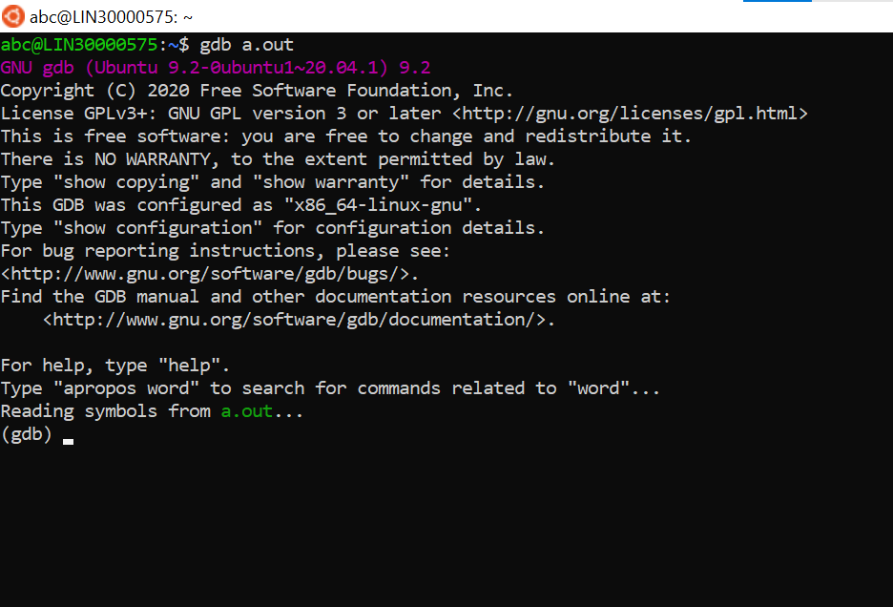

Step 5: List the code

  (gdb) *list*

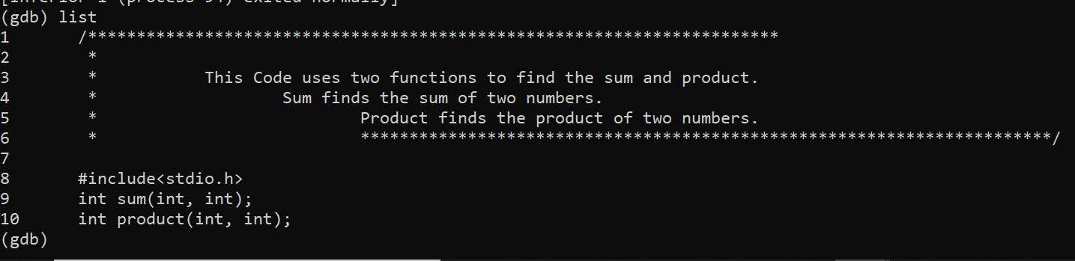

What do you observe ?

* It shows 10 lines from code in text format.

Step 6: If you want to list more than 10 lines, set the list size.

  (gdb)  *set listsize  25*

  (gdb)  *list*

What do you observe? ( Type *list 1* : Observe the output)

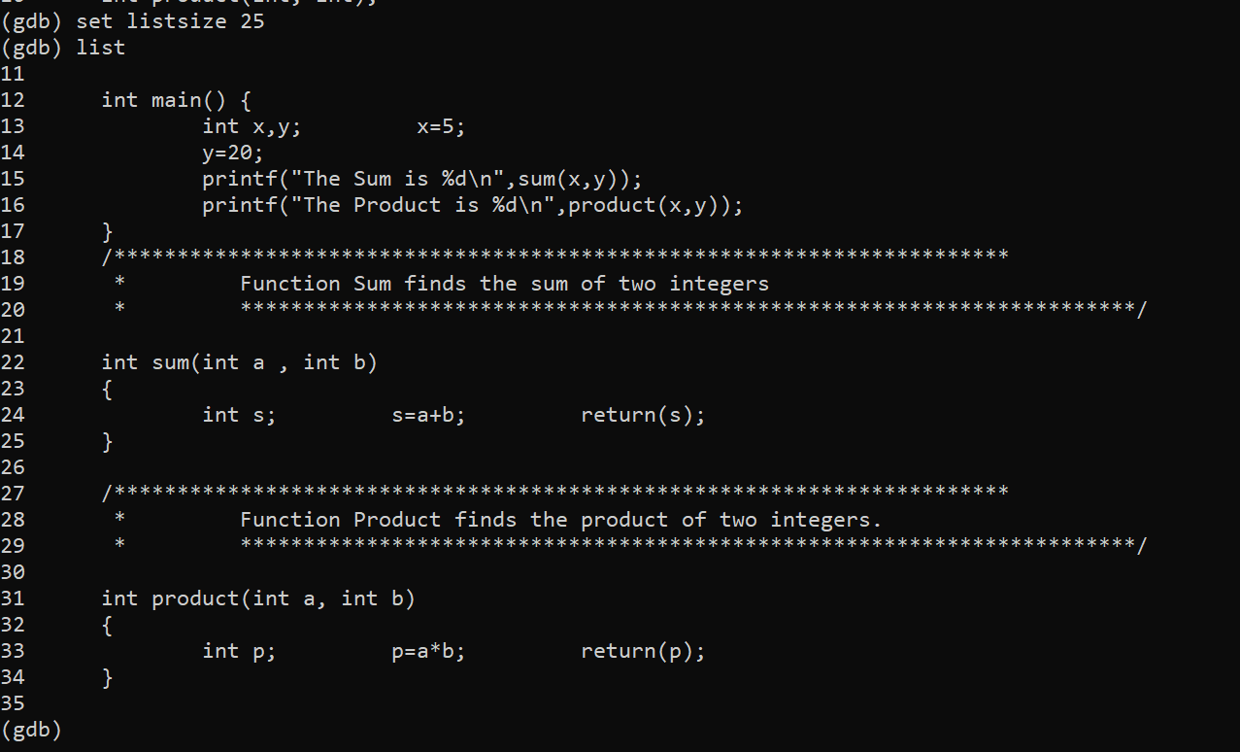

* Now its showing entire code from 0 to line 25.

Step 7: Run the code.

  (gdb)  *r*

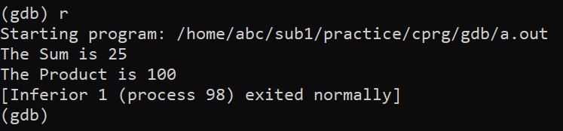

What do you observe ?

* Runs the program and display the output.

  Gdb says that the “ *program exited with code 023*”

What does this mean ?

* For me its showing process excited normally means it doesn’t find any error and compiled successfully.

Step 8: Quit gdb

  (gdb) *q*

Step 9: Edit the code. In the main function, type  *‘exit(0)*’  before the last *‘}’.*

* 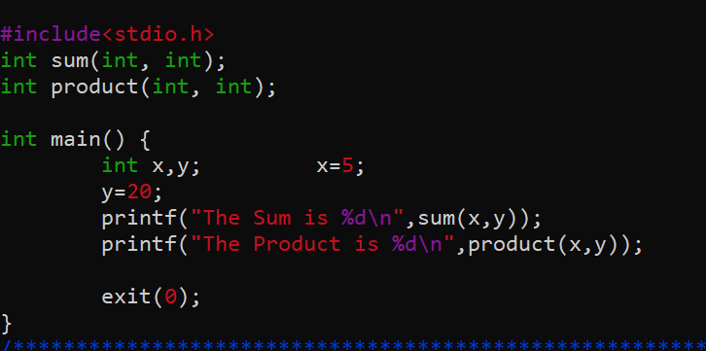 michigan

Step 10: Save and exit. Compile the code again with –g option. Invoke the output with gdb.

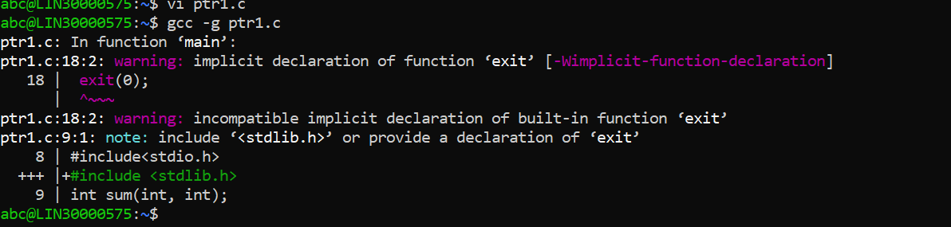

Step 11:Again run the program .

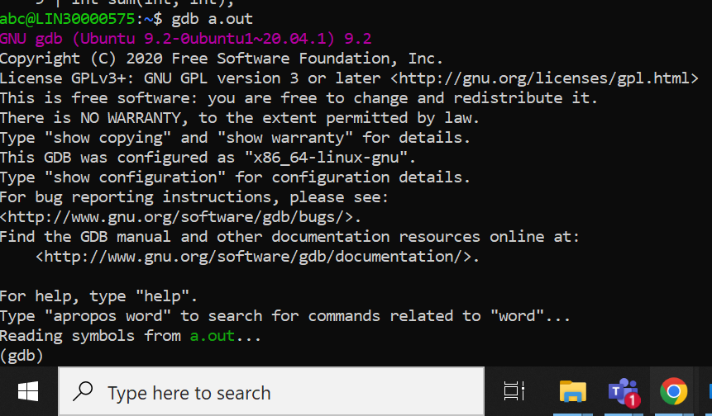

Now what do you observe  ?

* No change

Step 12: Redirect the output to a file.

  (gdb)    *r  >  outputfile*

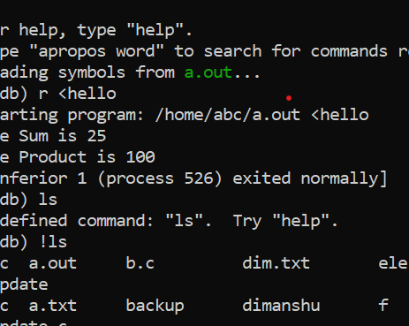

Step 13: quit gdb. List the contents of outputfile     *cat  outputfile*

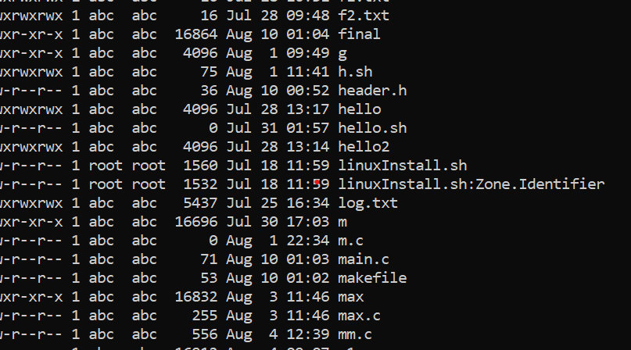

Step 14: Again invoke the output with gdb. List  40 lines of the code.

Step 15: Set breakpoint. At main, function sum and function product.

  (gdb)  *b  main* (gdb)  *b  23*

  (gdb)   *b  product.*

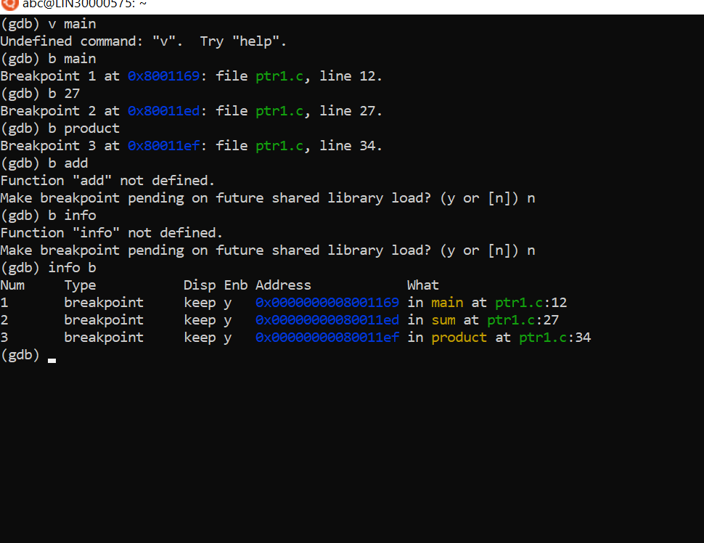

What do you  observe ?

* Breakpoints can be assigned using function name as well as line numbers.

Step 16: List information about breakpoint.

  (gdb) *info b*

What do you observe ?

* The first column displays the id of each breakpoint.

Step 17: Delete breakpoint  with id = 1

  (gdb)    *d   1*

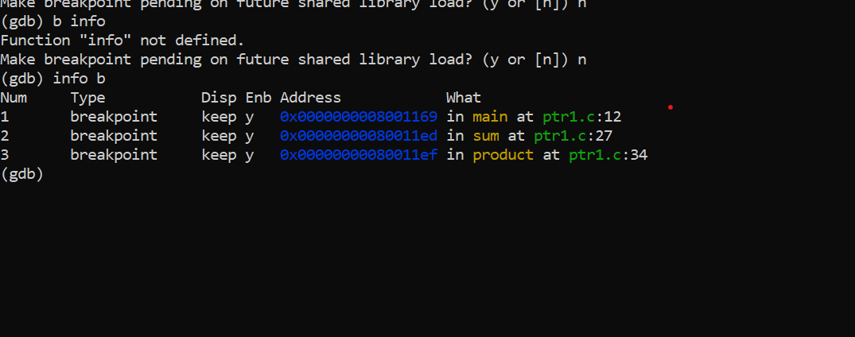

Step 18: Again list information on break points .

  What do you observe ?

Step 19: Again put a break point on main.

Step 20 : Run the program

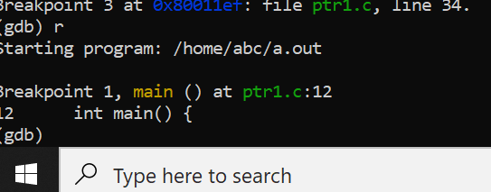

What do you observe  ?

* Gdb encounters the first breakpoint and waits for you.

Step 21:  To execute this line and go to next line, type the command n (next) and press enter.

  (gdb*)  n*

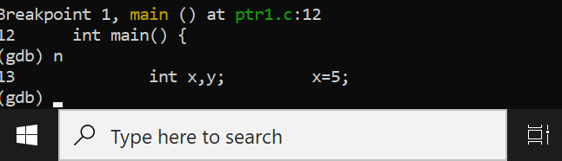

Step 22 : Again type n

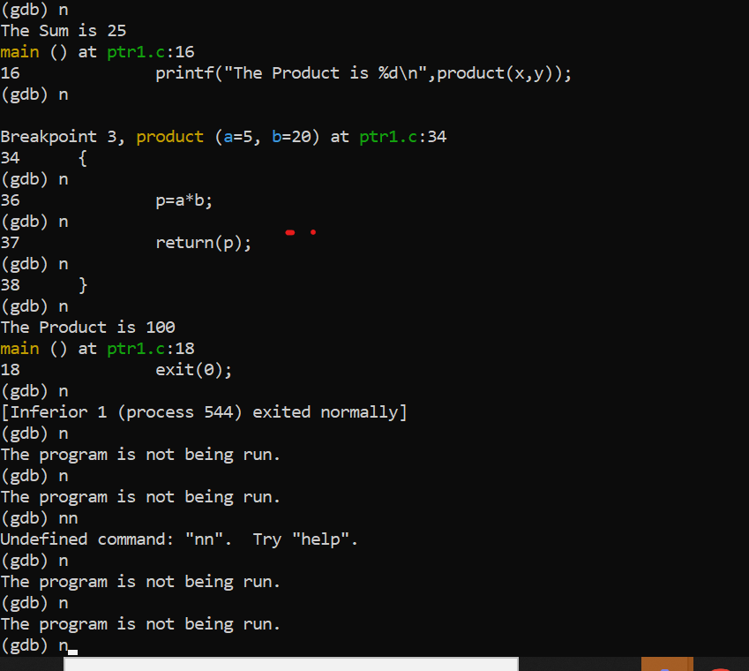

Step 23: Fnd out the value of a variable.

  (gdb) *p  x*

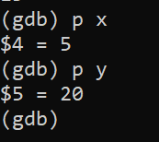

Step 23 :  Find the address of the variable.

  (gdb*)  p  &x*

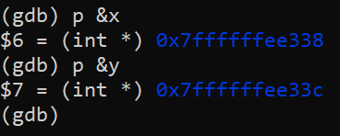

Step 24: Similarly find the value of variable y and address of y

What do you observe ? Can you explain the output ? Can you explain the address of variable x and variable y.

Step 25: Again execute the next line.

What do you observe ?

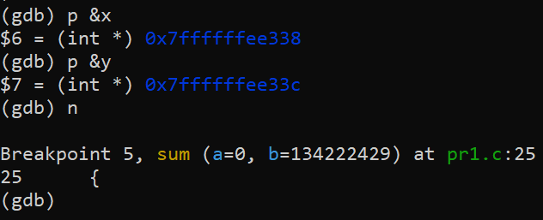

* Gdb has encountered the second breakpoint.

Step 26: You may enter the function and execute each line of function one by one.

  (gdb) *s*

 ( Note the difference between n (next) and s (step). To go inside a function we use the command  s.)

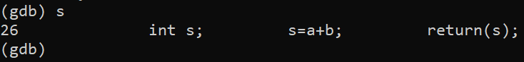

Step 27 : Find out the value and address of variable a and variable b. What do you  observe ?

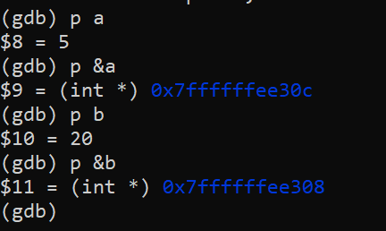

Step 30 : Execute the next line by typing ‘n’. Find out the value and address of variable s.

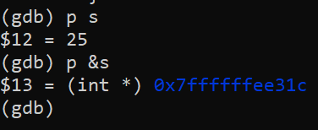

Step 31 : List out the number of active stack frames.

  (gdb) *bt*

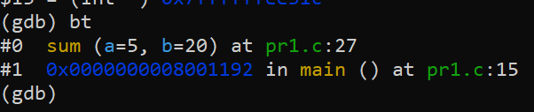

What do you observe ?

* Displays all the current variable that is stored in stack.

Step 32 : Get info about current frame.

  (gdb)  *info f*

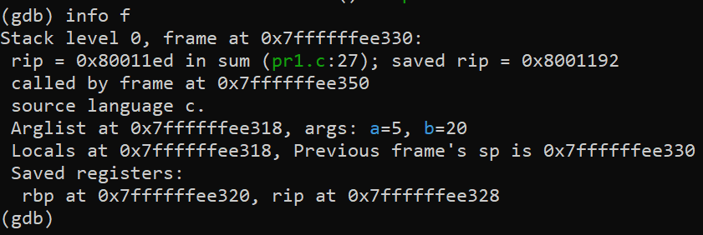

Step 33:  Move to previous frame i.e frame number 1

  (gdb*) f 1*

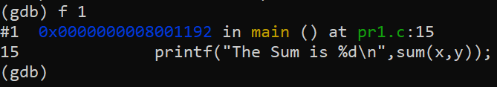

Step 34: List info about the current stack frame. What do you observe ?

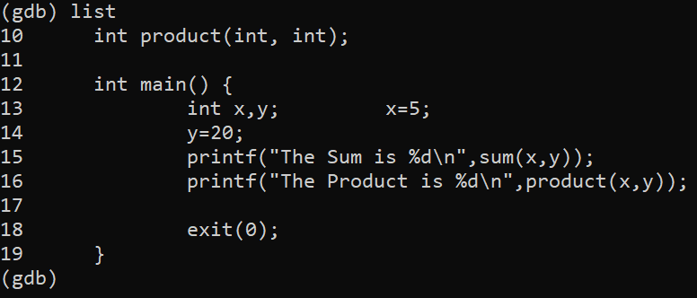

Step 35: Continue executing the code until you reach the next   breakpoint .

  (gdb) *c*

  (Command c stands for continue.)

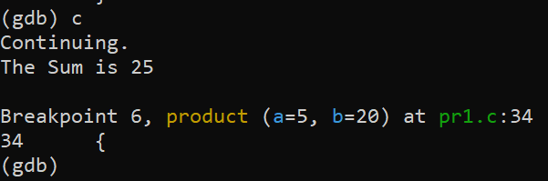

Step 36 : Again use the command c and press enter

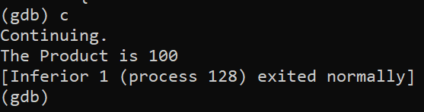

What do you observe ?

* Function of product executed successfully

*TYPE THE FOLLOWING CODE USING VI EDITOR*.

/\*\*\*\*\*\*\*\*\*\*\*\*\*\*\*\*\*\*\*\*\*\*\*\*\*\*\*\*\*\*\*\*\*\*\*\*\*\*\*\*\*\*\*\*\*\*\*\*\*\*\*\*\*\*\*\*\*\*\*\*\*\*\*\*\*

        This program finds the sum of n natural numbers , where n is         passed as a command line argument..

\*\*\*\*\*\*\*\*\*\*\*\*\*\*\*\*\*\*\*\*\*\*\*\*\*\*\*\*\*\*\*\*\*\*\*\*\*\*\*\*\*\*\*\*\*\*\*\*\*\*\*\*\*\*\*\*\*\*\*\*\*\*\*\*\*/

#include<stdio.h>

#include<stdlib.h>

int main(int argc, char\* argv[])

{

        int input ,sum, count;

        if (argc < 2)

        {

                printf("Enter the number as a command line arg\n");                 exit(1);

        }

        //We need to convert the argument string to number

        //Call Library Function atoi, which converts the string to number

        input = atoi(argv[1]);         sum = 0;

        for(count=1 ; count <=input ; count++)

        {

                sum = sum + count;

        }

        printf("The sum is %d\n",sum);

        return 0;

}

Step 1: Compile the code using gcc  with option –g and invoke gdb (gdb a.out)

* 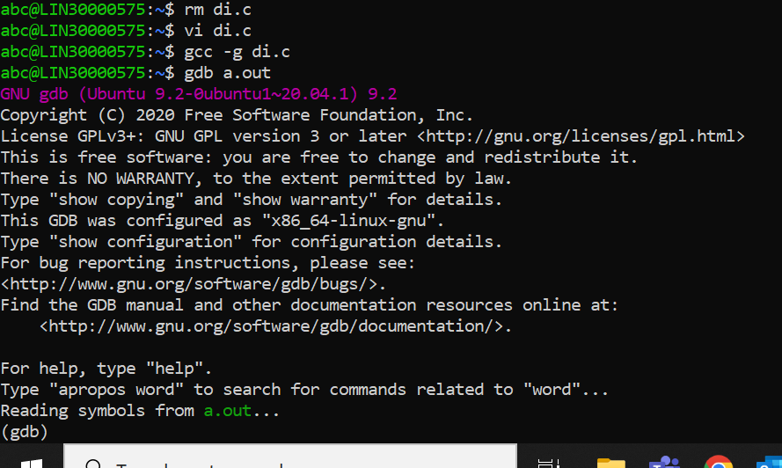

Step 2: Assign a breakpoint at main. (b main)

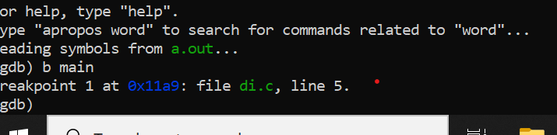

Step 3:  Breakpoints can be disabled and enabled using the following commands:

(gdb) *dis <id>*

(gdb*) en <id>*

Check the status of the breakpoint after disabling and enabling the breakpoint

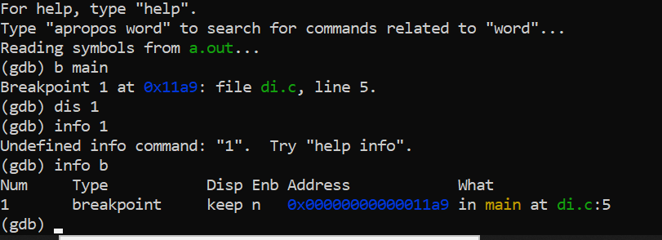

Step 4:A watchpoint is a special breakpoint that stops your program when the

  Value of  an expression changes. Let us put a watchpoint on variable sum in main.

 (gdb) *b main*

(gdb*) r  5      ( Here execute the code with command Line Argument  -5)* (gdb) *n*

(gdb) *watch  sum*

(gdb) *c*

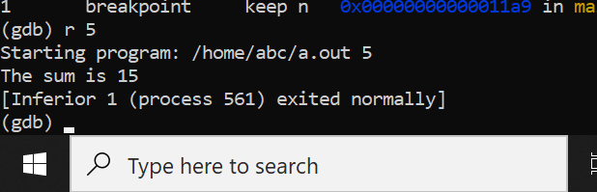

What do you observe  ?

* After you continue the program stops when  the value of the variable sum changes Press Enter to continue or n (next to execute next line of code)

*Note: When you run the program using command r , you can  provide the command line argument.(Which is 5 in this example)*

*Some more gdb  useful Commands*

To execute a shell command

 gdb> shell <cmd to execute>

To view the contents of a memory location

1. /15c <address>   //display 15 characters

To set a break with condition

    Consider the code below in myfile.c, where to break when i = 4

1. for (i = 0; i < 10; i++)
2. {      22  ret +=i;

               ....

     25  }

   gdb>break myfile.c:21 if (i == 4)

To view the assembly code with source

    gdb> disassem /m